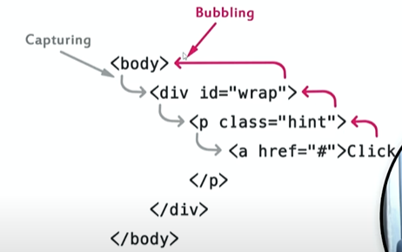

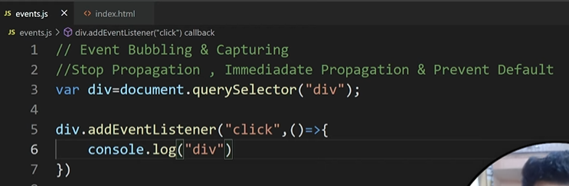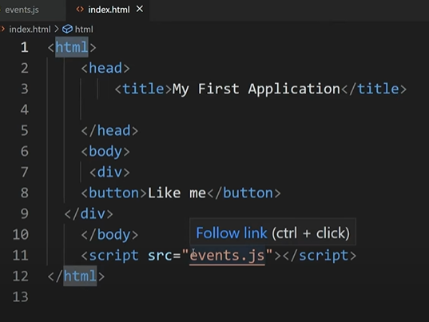**Event Bubbling**

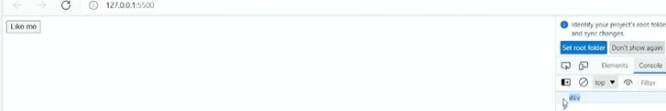

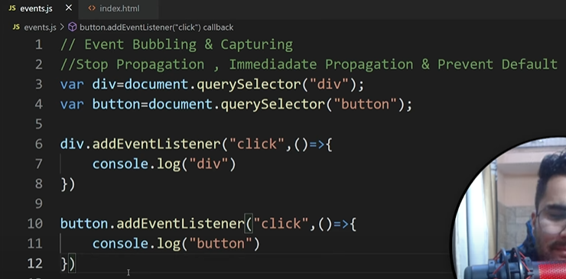

# 

# Event Capturing

# Stop Propagation

# 

# 

# Immediadate Propagation

# 

# 

# 

# Prevent Default

# Page not reload.

# Event Delegation

# 

# 

# 

# Solution (Event Delegation)

# stopImmediatePropagation vs stopPropagation

# <body>

# <div id="parent">

# <button id="child">Click me</button>

# </div>

# <script>

# const parent = document.getElementById('parent');

# const child = document.getElementById('child');

# // Parent event listener

# parent.addEventListener('click', function() {

# console.log('Parent clicked');

# });

# // Child event listener 1

# child.addEventListener('click', function(event) {

# console.log('Child clicked - Listener 1');

# // Use event.stopPropagation()

# event.stopPropagation();

# });

# // Child event listener 2

# child.addEventListener('click', function(event) {

# console.log('Child clicked - Listener 2');

# });

# </script>

# </body>

**With event.stopPropagation()**:

* "Child clicked - Listener 1"
* "Child clicked - Listener 2"

# child.addEventListener('click', function(event) {

# console.log('Child clicked - Listener 1');

# // Use event.stopImmediatePropagation()

# event.stopImmediatePropagation();

# });

# **With** event.stopImmediatePropagation():

* + "Child clicked - Listener 1"